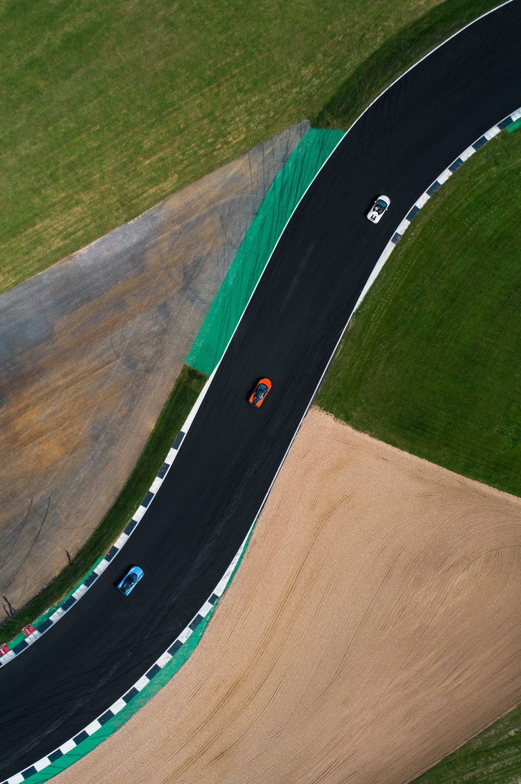

**](https://www.smartsheet.com/try-it?trp=12265&utm_source=template-word&utm_medium=content&utm_campaign=Sample+Sports+Sponsorship+Proposal-word-12265&lpa=Sample+Sports+Sponsorship+Proposal+word+12265)Microsoft Word Sports Sponsorship   
Proposal Template Example**

Sponsorship Proposal for:

Velocity Cup 20XX

|  |  |  |
| --- | --- | --- |
| Prepared By |  | Date |
| Makara McLean | | 10/11/20XX |

Contents of This Sponsorship Proposal

1. INTRODUCTION 2

2. ABOUT THE SPONSORSHIP 2

3. SPONSORSHIP OPPORTUNITIES 3

4. BENEFITS OF SPONSORING 3

5. SPONSORSHIP PACKAGES 4

6. CUSTOM SPONSORSHIP OPPORTUNITIES 5

7. MARKETING AND PROMOTION PLAN 5

8. AUDIENCE REACH & MEDIA COVERAGE 6

9. SPONSOR ACTIVATION OPPORTUNITIES 6

10. PREVIOUS SPONSORSHIP SUCCESSES 7

11. contact information 7

|  |  |
| --- | --- |
| Introduction | Thank you for considering this sponsorship proposal for **Velocity Cup 20XX,** a premier auto-racing event that combines speed, skill, and entertainment to captivate racing fans nationwide. This proposal outlines the sponsorship benefits and how partnering with **Velocity Cup 20XX** gives your brand high-impact visibility, engagement with a dedicated fanbase, and alignment with a thrilling motorsport experience. |

|  |  |
| --- | --- |
| About the Sponsorship | **Velocity Cup 20XX** happens on **April 20-22, 20XX**, at the **Thunderline Raceway** in **Riverton, TX**. The event expects to attract over **50,000 attendees** across three days, including racing enthusiasts, families, and auto industry professionals. This racing event will feature top drivers competing in multiple race classes, interactive fan zones and showcase the latest racing technology. The Velocity Cup aims to deliver a memorable experience that celebrates the spirit of competition and cutting-edge automotive innovation. |

|  |  |
| --- | --- |
| 1. Sponsorship Opportunities | Sponsors have several high-impact opportunities to engage with the audience:   * **Main Race Sponsorship**: Gain branding as the title sponsor of the primary race, with extensive logo placement on banners and promotional materials. * **Vehicle Branding**: Place your logo on race cars, driver suits, and pit crew uniforms for ongoing brand visibility throughout the event. * **Fan Zone Sponsorship**: Brand the interactive fan area with immersive experiences and direct engagement with attendees. * **Digital and Social Media Presence**: Showcase your brand with prominent logo placement on event websites, social media posts, and digital marketing campaigns. |

|  |  |
| --- | --- |
| 1. Benefits of Sponsoring | By sponsoring **Velocity Cup 20XX**, your brand will:   * **Reach a loyal fanbase** of racing enthusiasts who value brand affiliations within the motorsports community. * **Maximize brand visibility** through logo placement on race cars, signage, event merchandise, and media coverage. * **Engage directly with fans** via on-site activation, providing a memorable brand experience that fosters loyalty. |

|  |  |
| --- | --- |
| 1. Sponsorship Packages | Below are the sponsorship packages available for **Velocity Cup 20XX**, each offering distinct benefits to meet varying marketing goals. Each tier ensures your brand achieves impactful visibility and engagement tailored to the event's audience. |
| **Diamond Suit with solid fillPlatinum** Sponsorship  Package | |
| The platinum package includes title sponsorship of the race, exclusive logo placement on all vehicles, driver suits, and the official event stage, 50 VIP passes for premium seating, exclusive access to meet drivers, a reserved corporate hospitality suite, press release features, a personalized social media campaign, and an interview with the sponsor in *RacePulse Monthly.* | |
| **Diamond Suit with solid fillGold** Sponsorship  Package | |
| The gold package includes branding on all race cars and pit crew uniforms, prominent logo placement on race day banners and posters, 30 VIP passes, access to the VIP lounge, recognition in email newsletters, event posters, and mentions in live social media updates during race weekend. | |
| **Diamond Suit with solid fillSilver** Sponsorship Package | |
| The silver package includes logo placement in the fan zone and on select merchandise items, an exhibit booth at the fan experience area, 15 complimentary tickets to general seating, brand presence in event recap videos, event program recognition, and social media posts before and during the event. | |
| **Diamond Suit with solid fillBronze** Sponsorship  Package | |
| The bronze package includes logo placement in the event program, one social media shout-out during the event, five general admission tickets, inclusion in event thank-you posts, and acknowledgment on the event's official website. | |

|  |  |
| --- | --- |
| 1. Custom Sponsorship Opportunities | We offer sponsorship options for brands with more specific goals in mind. Custom options include co-branded racing challenges, exclusive product showcase spaces, and photo zones. These personalized packages allow sponsors to align closely with the event's excitement and audience interests. |

|  |  |
| --- | --- |
| 1. Marketing and Promotion Plan | Our promotional strategy for **Velocity Cup 20XX** includes:   * **Pre-Event Digital Campaigns**: Targeted social media ads, countdown posts, and event teasers. * **Press and Media Partnerships**: Coverage in *RacePulse Monthly* and *AutoFocus Digest*. * **During-Event Live Updates**: Real-time social media coverage, including race highlights, interviews, and sponsor spotlights. * **Post-Event Recaps**: Video highlights and photo albums shared on the event's website and social media. |

|  |  |
| --- | --- |
| 1. Audience Reach and Media Coverage | The event anticipates **50,000+ attendees** on-site and an additional **250,000 online viewers** through live streaming and media coverage. **Demographics** include a mix of racing fans aged **18–55**, with a solid male audience and increasing female viewership. Past events attracted media attention from ***AutoFocus Digest*** and ***Trackline Media***, ensuring significant brand visibility for sponsors. |

|  |  |
| --- | --- |
| 1. Sponsor Activation Opportunities | Create memorable brand interactions through the following:   * **Interactive Fan Booths**: Engage attendees with fun activities like virtual racing simulators or branded photo stations. * **Exclusive Driver Meet-and-Greets**: Co-host intimate sessions for fans to meet drivers and receive autographed memorabilia. * **Social Media Contests and Giveaways**: Run branded challenges for attendees to win event tickets, VIP access, or sponsor merchandise. * **Branded Grandstand Areas**: Sponsors can offer fans an upgraded viewing experience with branded seating in prime locations. |

|  |  |
| --- | --- |
| 1. Previous Sponsorship Successes | Our previous event, **RallyChamp 20XX**, welcomed **40,000 fans** and generated over **300,000 digital impressions**. Past sponsors reported significant engagement boosts and brand recognition increases. **TorqueOne Performance**, a prior sponsor, stated, "Partnering with this event connected directly with racing fans who truly appreciate quality and innovation." |

|  |  |
| --- | --- |
| 1. Contact Information | **Everett Crosse** Sponsorship Director, **RaceReach** **Events** Email: **everett.crosse@racereachevents.com** Phone: **(555) 789-1234** |

Document Sign-Off

|  |  |  |
| --- | --- | --- |
| Prepared By |  |  |
| Makara McLean | | |

|  |
| --- |
| Reviewed By |
| Krista Ahmed | |

|  |
| --- |
| Approval |
| Sarah Goodwin | |

|  |
| --- |
| **DISCLAIMER**  Any articles, templates, or information provided by Smartsheet on the website are for reference only. While we strive to keep the information up to date and correct, we make no representations or warranties of any kind, express or implied, about the completeness, accuracy, reliability, suitability, or availability with respect to the website or the information, articles, templates, or related graphics contained on the website. Any reliance you place on such information is therefore strictly at your own risk. |