**](https://www.smartsheet.com/try-it?trp=12149&utm_source=template-word&utm_medium=content&utm_campaign=Blank+Value+Stream+Future+State+Map-word-12149&lpa=Blank+Value+Stream+Future+State+Map+word+12149)Value Stream Future State Map   
Template**

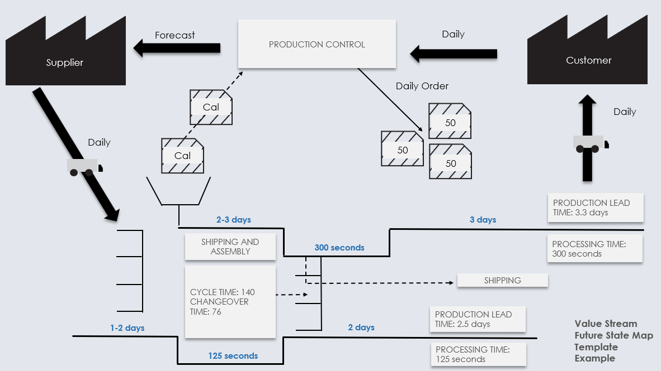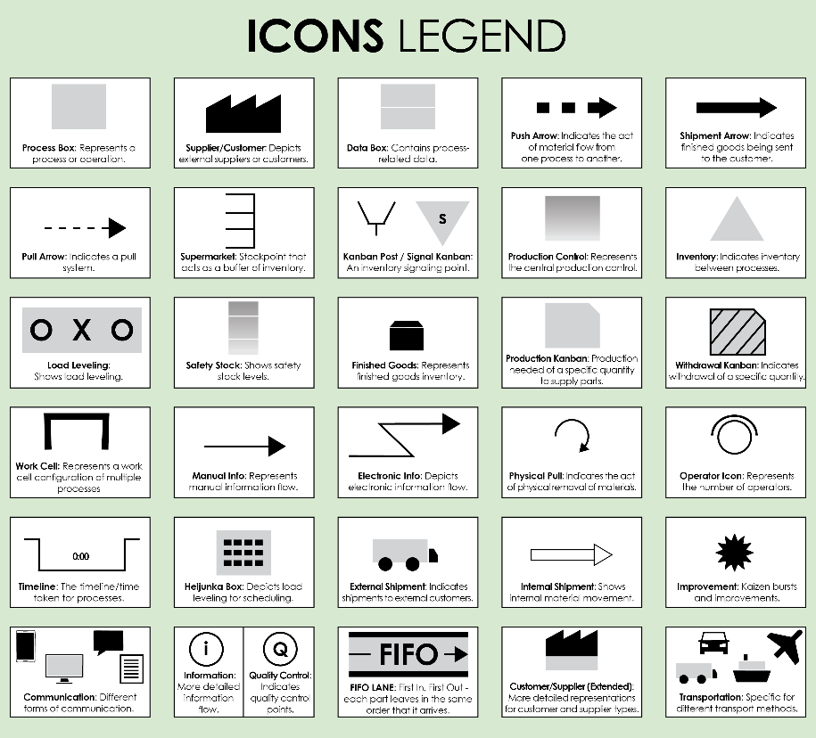Use this map to visualize the ideal process flow after improvements and optimizations are implemented. This is to illustrate the "after."

For descriptions, see **VSM Icons Legend** on Page 4 of this document.

To create your own VSM, copy and paste icons from the **VSM Icons** on Page 5 of this document.

**Value Stream Future State Map Template**

To create your own VSM, copy and paste icons from the **VSM Icons** on Page 5 of this document.

**Value Stream Future State Map Template Example**

**125 seconds**

**3 days**

**2 days**

**300 seconds**

**2-3 days**

**1-2 days**

Daily

Forecast

Daily

Daily

Daily Order

PRODUCTION LEAD TIME: 3.3 days

PROCESSING TIME: 300 seconds

PRODUCTION LEAD TIME: 2.5 days

PROCESSING TIME: 125 seconds

SHIPPING AND ASSEMBLY

SHIPPING

Supplier

Customer

Cal

Cal

50

50

50

PRODUCTION CONTROL

CYCLE TIME: 140

CHANGEOVER TIME: 76

NOTES

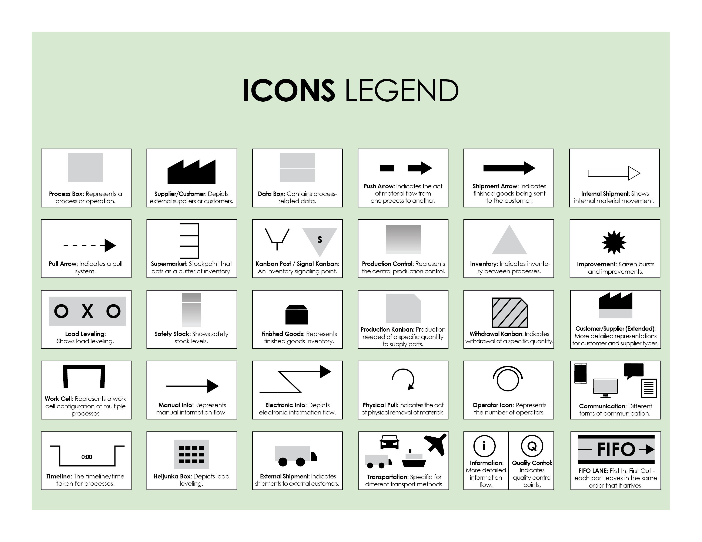

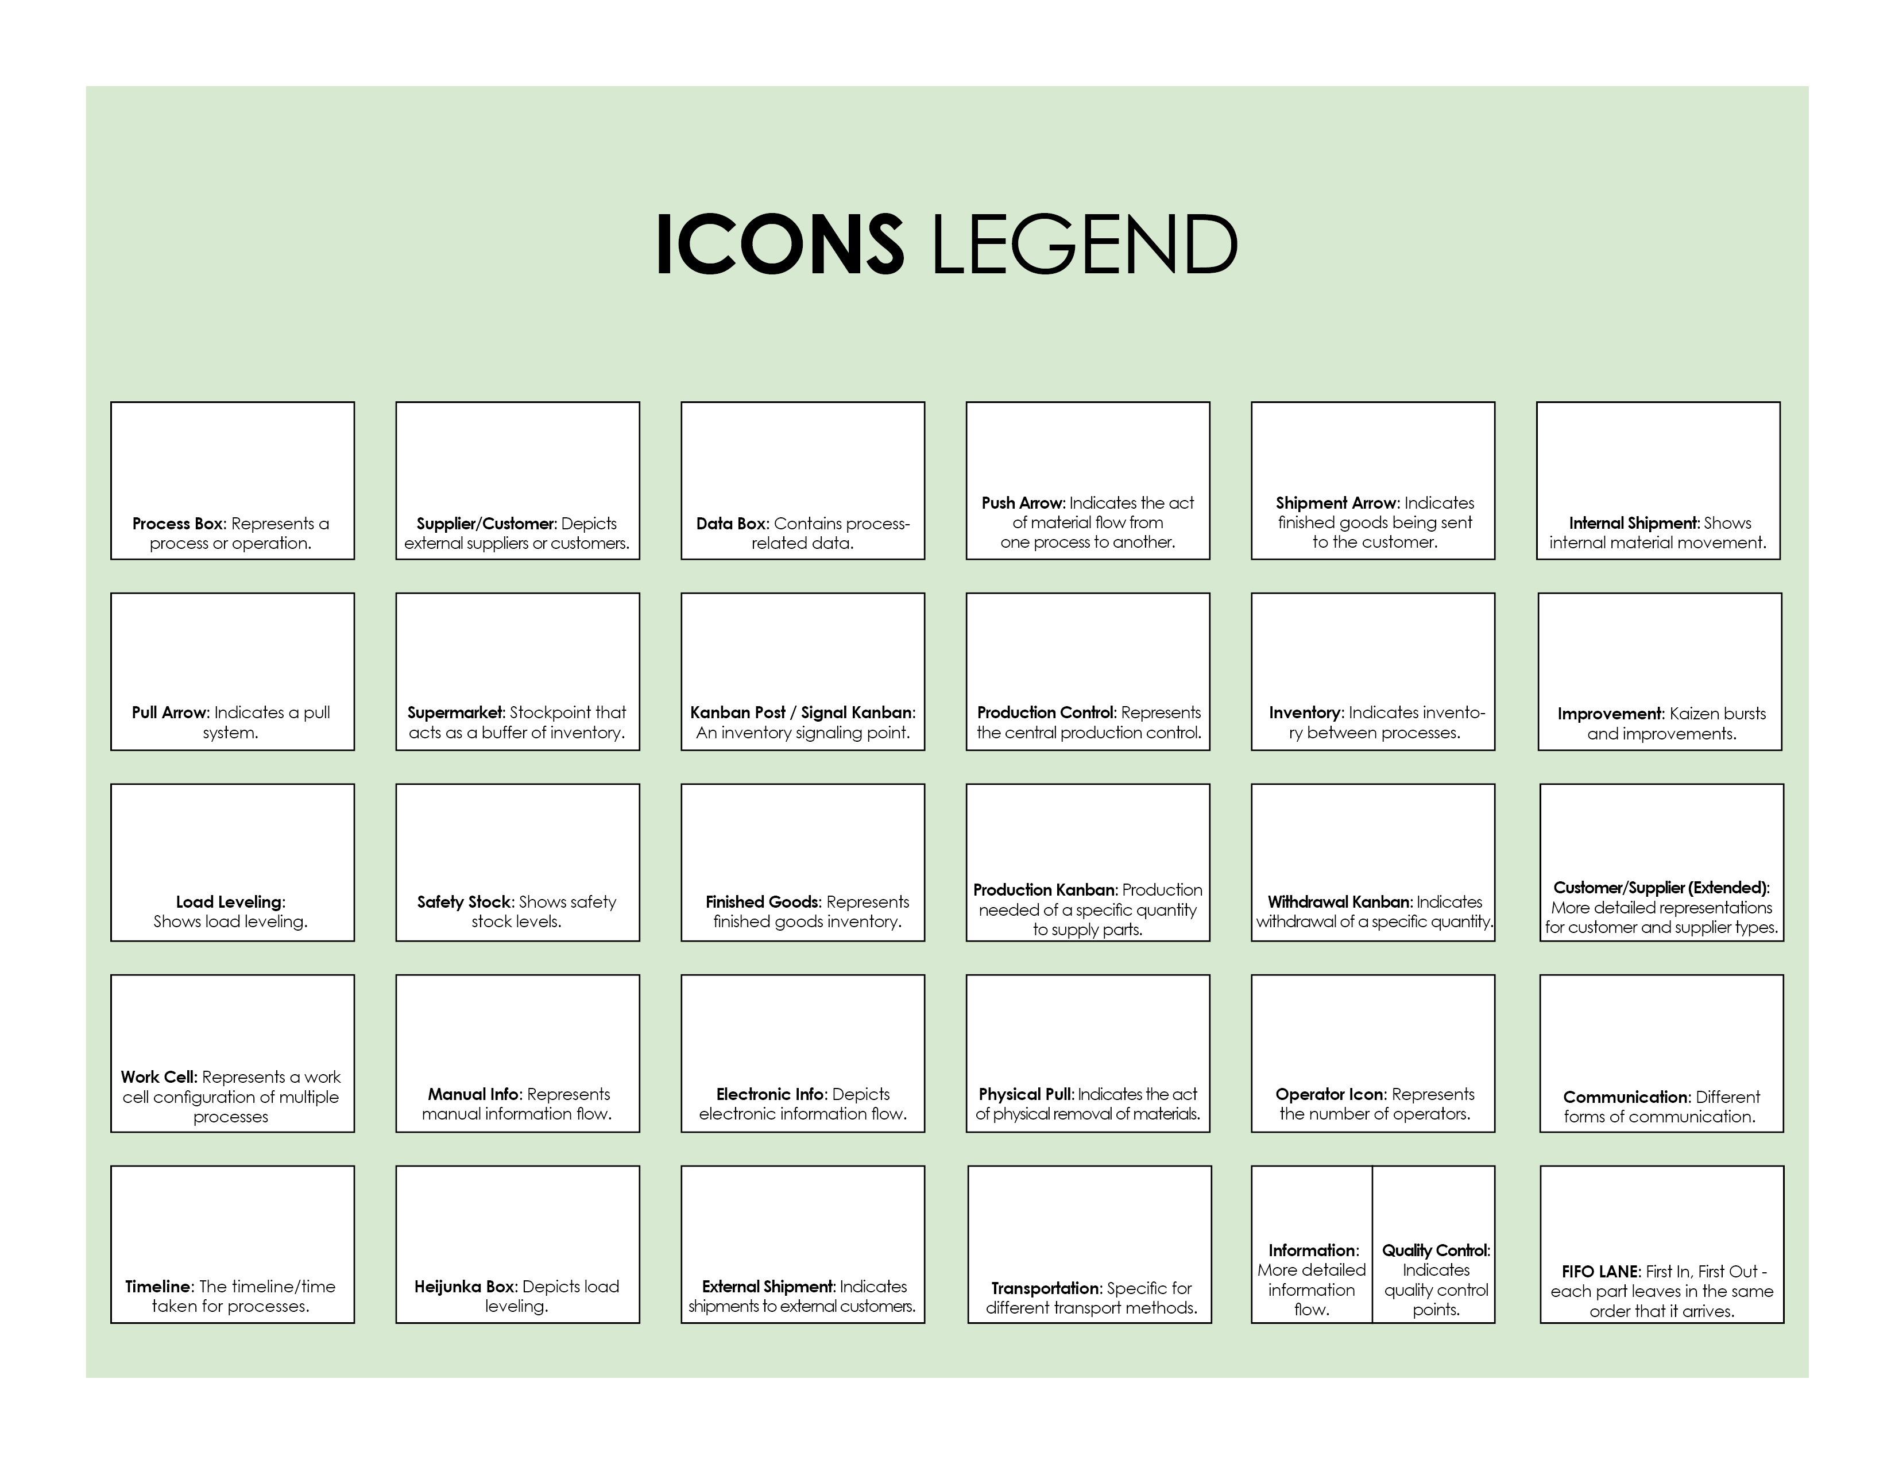

Copy and paste the icons below to create your own VSM.



|  |
| --- |
| **DISCLAIMER**  Any articles, templates, or information provided by Smartsheet on the website are for reference only. While we strive to keep the information up to date and correct, we make no representations or warranties of any kind, express or implied, about the completeness, accuracy, reliability, suitability, or availability with respect to the website or the information, articles, templates, or related graphics contained on the website. Any reliance you place on such information is therefore strictly at your own risk. |