**](https://www.smartsheet.com/try-it?trp=12149&utm_source=template-word&utm_medium=content&utm_campaign=Sample+Lead+Time+Ladder+VSM-word-12149&lpa=Sample+Lead+Time+Ladder+VSM+word+12149)Lead Time Ladder VSM  
Template Example**

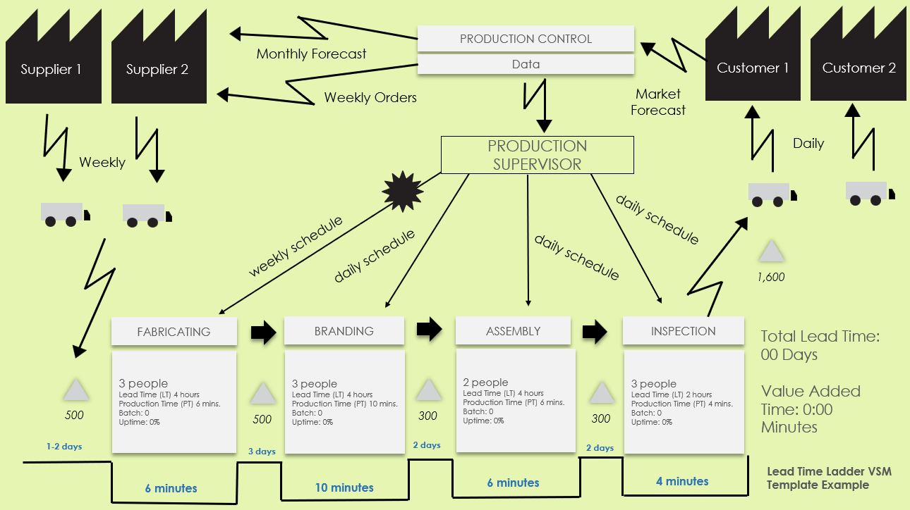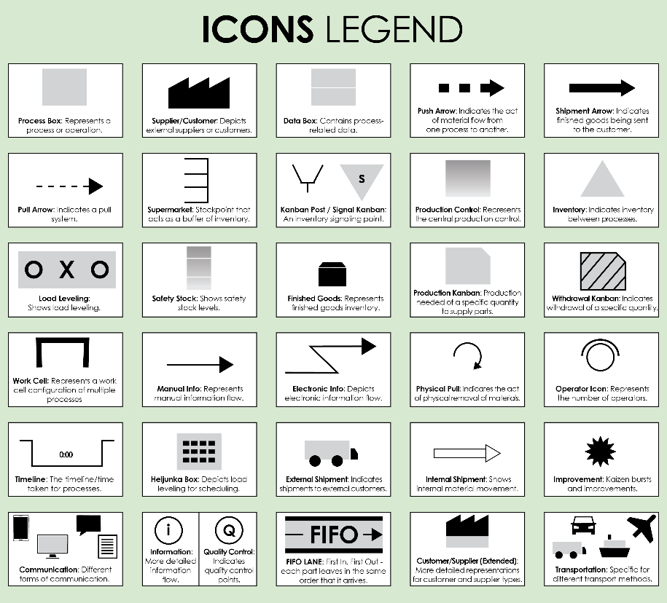Use this map to illustrate and track lead times and cycle times across different stages to identify delays and areas for speed improvement.

For descriptions, see **VSM Icons Legend** on Page 4 of this document.

To create your own VSM, copy and paste icons from the **VSM Icons** on Page 5 of this document.

PRODUCTION SUPERVISOR

Market Forecast

**Lead Time Ladder VSM Template Example**

Supplier 2

Supplier 1

**2 days**

**2 days**

**1-2 days**

**3 days**

**6 minutes**

Total Lead Time: 00 Days

Value Added Time: 0:00 Minutes

*1,600*

daily schedule

daily schedule

PRODUCTION CONTROL

Monthly Forecast

Weekly

INSPECTION

**10 minutes**

Data

ASSEMBLY

3 people

Lead Time (LT) 4 hours

Production Time (PT) 10 mins.

Batch: 0

Uptime: 0%

BRANDING

*500*

Customer 1

Daily

Customer 2

Weekly Orders

3 people

Lead Time (LT) 4 hours

Production Time (PT) 6 mins.

Batch: 0

Uptime: 0%

FABRICATING

*500*

*300*

**6 minutes**

2 people

Lead Time (LT) 4 hours

Production Time (PT) 6 mins.

Batch: 0

Uptime: 0%

*300*

3 people

Lead Time (LT) 2 hours

Production Time (PT) 4 mins.

Batch: 0

Uptime: 0%

**4 minutes**

weekly schedule

daily schedule

NOTES

To create your own VSM, copy and paste icons from the **VSM Icons** on Page 5 of this document.

**Lead Time Ladder VSM Template**

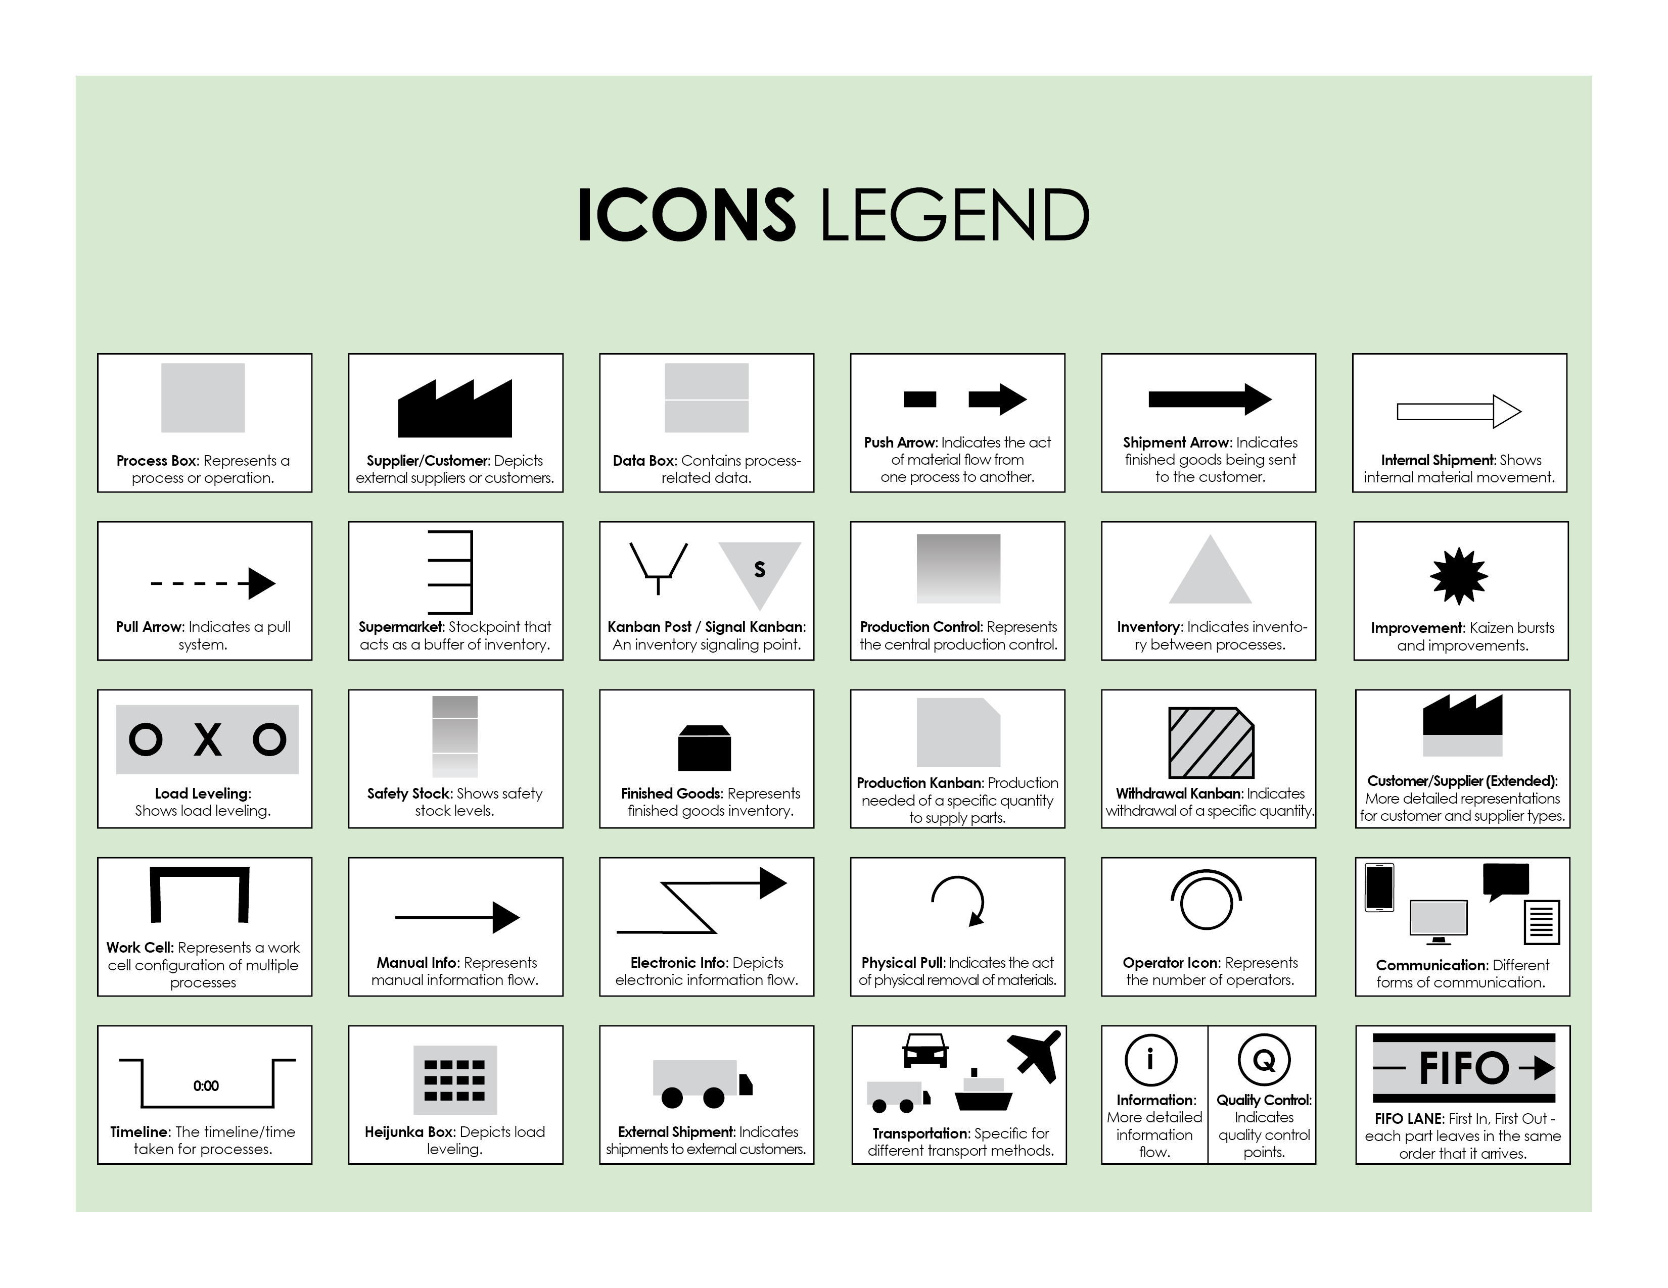

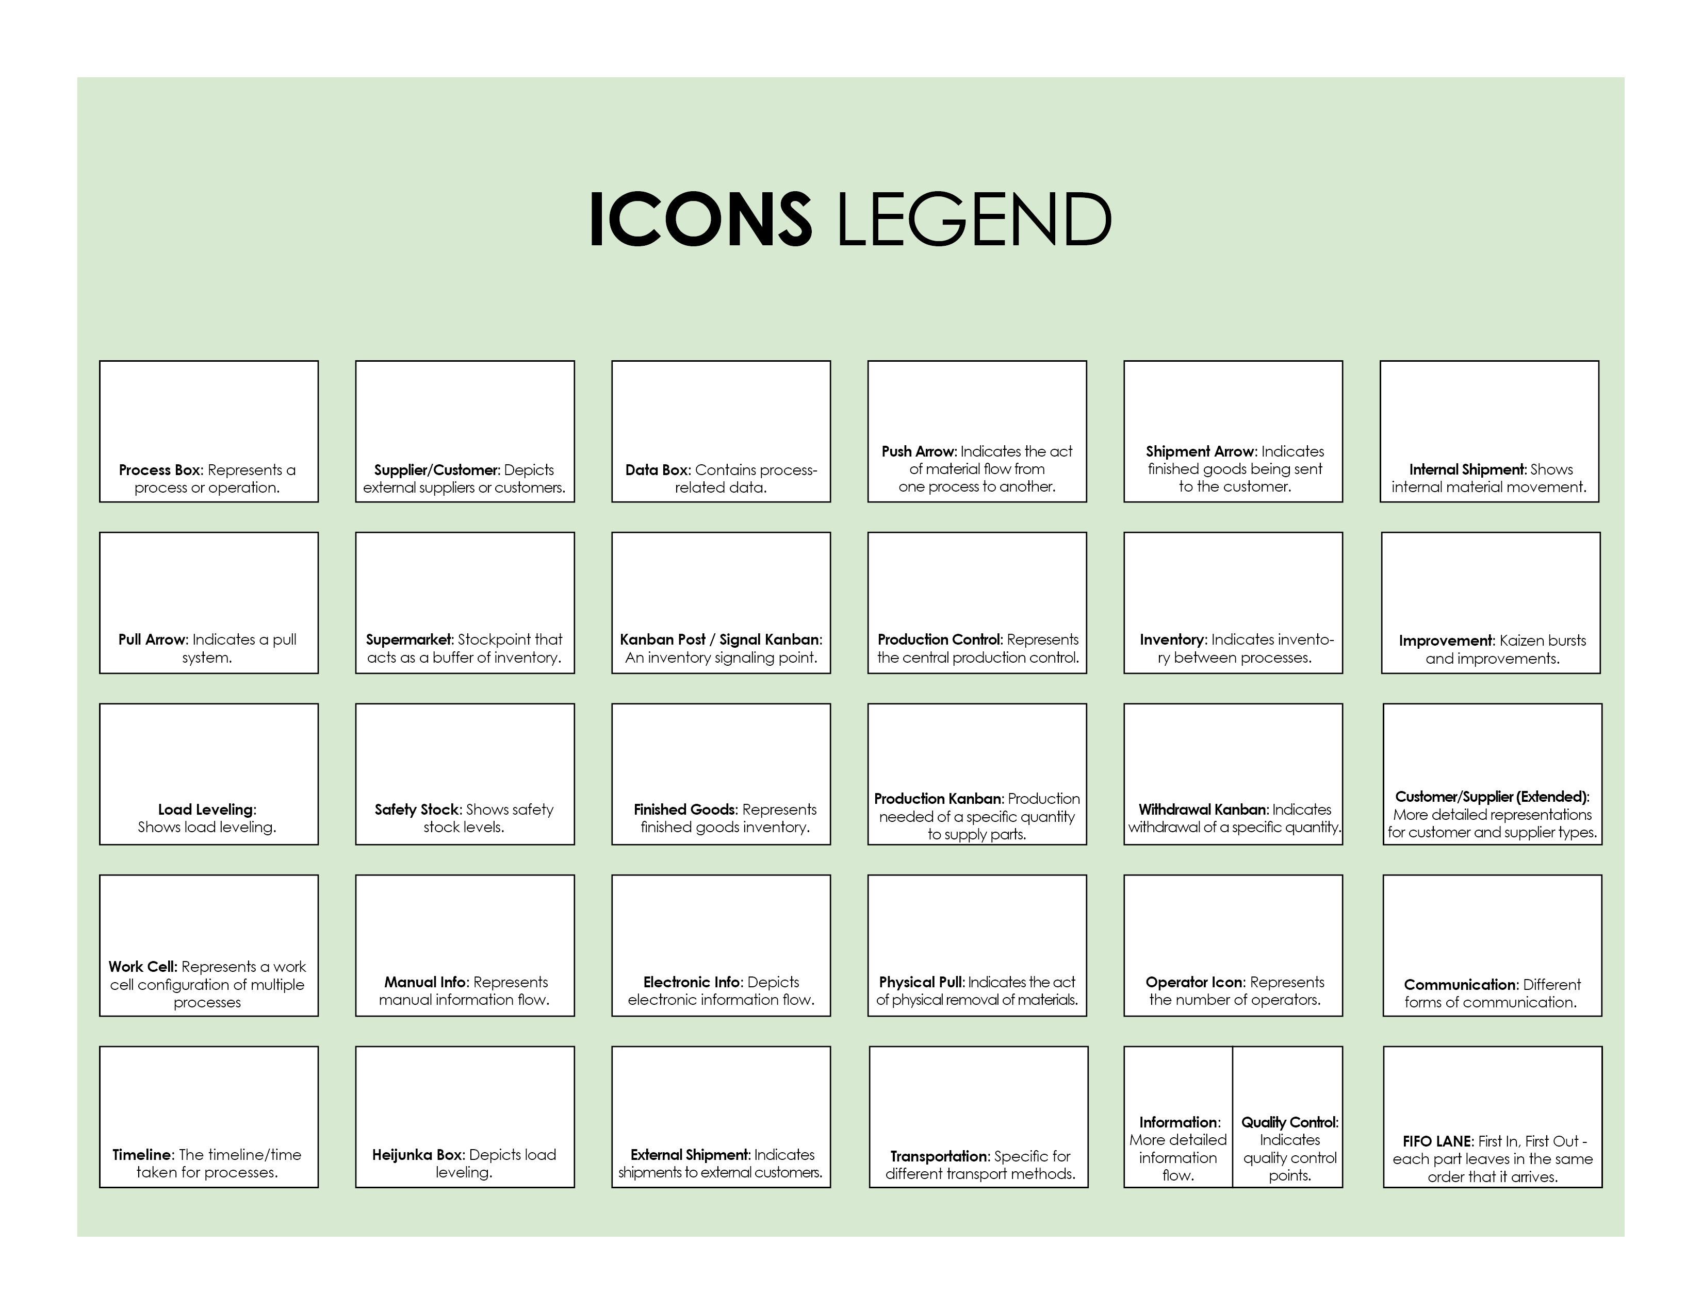

Copy and paste the icons below to create your own VSM.



|  |
| --- |
| **DISCLAIMER**  Any articles, templates, or information provided by Smartsheet on the website are for reference only. While we strive to keep the information up to date and correct, we make no representations or warranties of any kind, express or implied, about the completeness, accuracy, reliability, suitability, or availability with respect to the website or the information, articles, templates, or related graphics contained on the website. Any reliance you place on such information is therefore strictly at your own risk. |